**Name: Ayush Vaze**

**Roll No: TE A 76**

**Seminar Title: Smart City using Artificial Intelligence.**

**Abstract:**

The growth of urban areas has led to a significant increase in traffic congestion, impacting both quality of life and economic efficiency. Traditional traffic management systems usually struggle to manage the traffic controls. Aiming that reducing the traffic congestion and making the city smarter by improving the quality of life using Artificial Intelligence and Machine Learning Models. This paper introduces the use of sensors and cameras with computer vision technique. Smart signals with good cameras with advanced sensors and communication capabilities, can collect real-time data on traffic flow and environmental conditions. By analysing this data using AI and ML algorithms, these signals can intelligently adapt traffic patterns to optimize traffic flow and reduce congestion. Machine learning models can be trained on historical traffic data to predict future trends and peak traffic hours, enabling proactive adjustments to signal timings. The system also prioritizes emergency vehicles and public transportation when necessary, ensuring efficient movement across critical routes. The paper demonstrates a significant improvement in traffic flow and reduction in wait times at intersections, contributing to more efficient and environmentally friendly urban mobility. Implementing this solution in cities could lead to faster travel times and a decrease in traffic-related emissions. Furthermore, smart signals can integrate with other smart city infrastructure, such as connected vehicles and intelligent transportation systems, to facilitate seamless and efficient traffic management. In conclusion, the integration of AI and ML-powered smart signals into smart city traffic management systems offers a promising solution to address the challenges of urban congestion. These signals can optimize traffic flow, reduce pollution, and improve overall quality of life for city residents.

**Motivation:**

As the population is increasing, the number of vehicles are also increasing leading to more traffic congestion. To reduce traffic, smart traffic signals can be used with Artificial Intelligence and Machine Learning technologies. This system can dynamically adjust the signals according to live traffic conditions using cameras. This can significantly improve the quality of life in cities.

**Flowchart Diagram:**

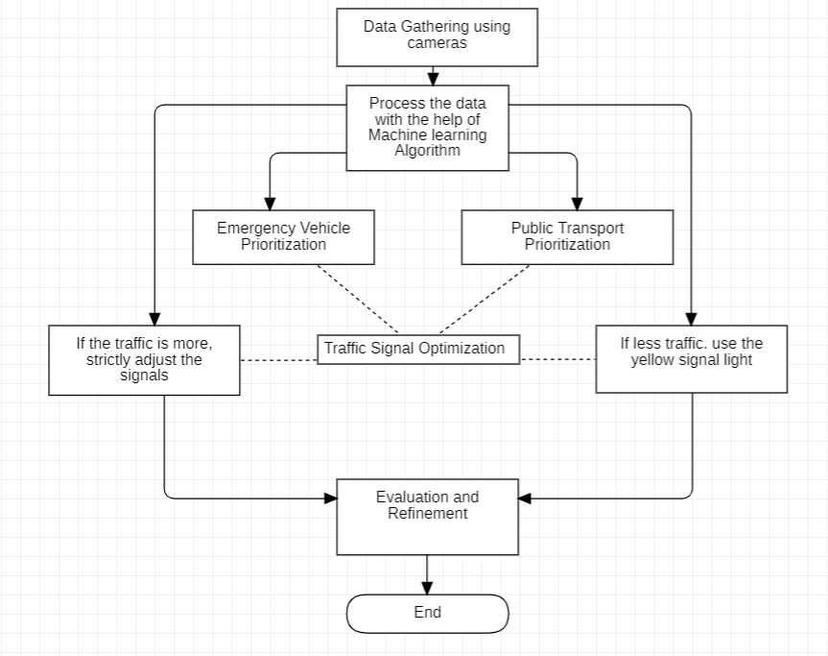

1. **Data Collection:**
   * **Sensors and Cameras:** Collect real-time traffic data and environmental data .
2. **Data Pre-processing:**
   * **Cleaning:** Remove noise or errors from the collected data.
   * **Feature Extraction:** Extract relevant features from the data (e.g., traffic density, average speed).
3. **Machine Learning Model Training:**
   * **Historical Data:** Train machine learning models on historical traffic data.
   * **Prediction:** Predict future traffic patterns and peak hours.
4. **Traffic Signal Optimization:**
   * **Algorithm:** Develop algorithms to optimize traffic signal timings based on real-time data and predictions.
   * **Adaptation:** Adjust signal timings dynamically to minimize congestion.
5. **Emergency Vehicle Prioritization:**
   * **Detection:** Detect emergency vehicles (e.g., ambulances, fire trucks) using sensors or cameras.
   * **Priority:** Grant priority to emergency vehicles at intersections.
6. **Public Transportation Prioritization:**
   * **Detection:** Detect public transportation vehicles (e.g., buses).
   * **Priority:** Give priority to public transportation vehicles during peak hours.
7. **Evaluation and Refinement:**
   * **Metrics:** Evaluate the system's performance using metrics like traffic flow, wait times, and emissions.
   * **Improvement:** Continuously refine the system based on evaluation results.